**Question 1**

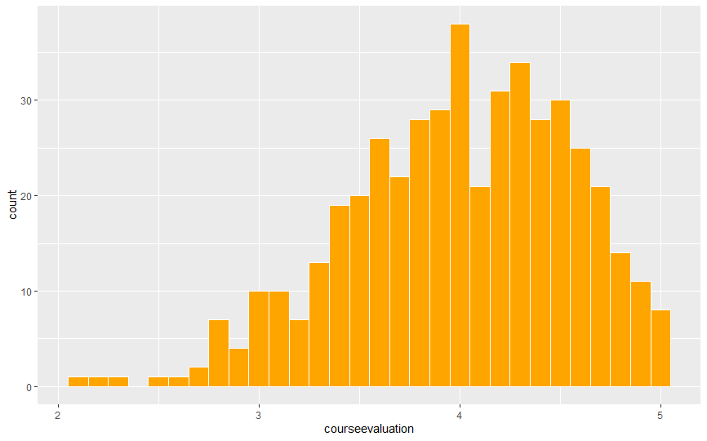

The graph above is not a normal distribution since the distribution does not have the perfect bell shape. The distribution is skewed more to the left which means the course evaluation values are smaller. The distribution shows that there are more bins to the left. When the mean and standard deviation is calculated for the course evaluation, the mean is 3.99 and the standard deviation is 0.55. The course evaluation score of 3 is 2 standard deviation away from the mean. Thus, course evaluation score of 3 is far away from the central number, 3.99 but 2 standard deviation or approximately 1.

**Question 2**

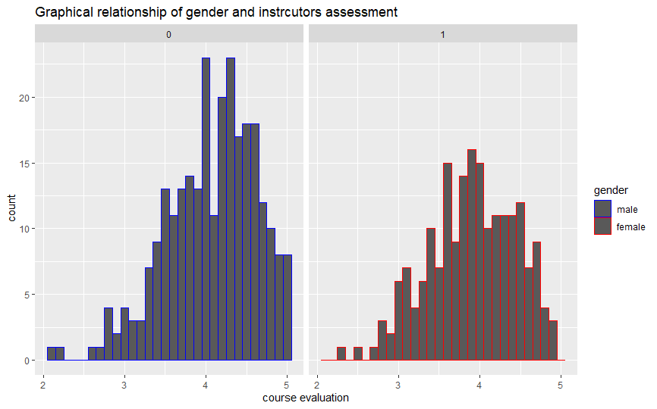

From the graph, male instructors have higher score than female instructors. Additionally, both graphs are skewed to the left which means both instructors scored lower values since there are more bins to the left from the mean 3.99. Most of observations are clustered around the mean. Most of the observation are found within 2 standard deviation away from the mean (mean= 3.99, standard deviation =0.55).

On the average male instructors had higher score away from the mean than the female instructors. So, on the average students prefer male instructors than female. From the gragh, the male instructors have higher score on the average than female. Students are of the opinion that the male professors teaching style is more effective and enhance learning. Additionally, I would recommend a teaching workshop for female teachers to equip them with the needed skills to meet students’ needs. Working conditions should be improved to encourage both male and female teachers to motivate them. This could include offering paid vacations, tenure track positions, and allowances.

**Question 3**

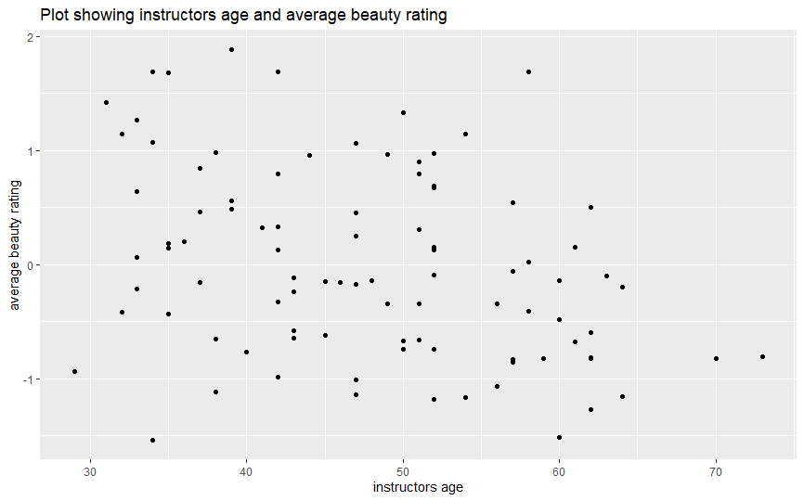

The plots on the graph suggest a majority of the professors are between the ages 30 and 65 years. The highest beauty scores (above 1.5) were among professors between the ages of 34 and 42 years. However, a professor closer to 60 years was scored 1.7. The lowest beauty scores -0.48 and -0.5 was a 34 year and a 60-year-old instructor respectively. This means a professor’s age has less influence on their beauty rating.

Majority of the professors are 50 years and below. At a glance, it appears there were equal number of professors rated above and below average beauty of 0.

From 30 to 40 years and 1.5 to - 0.2 on the average beauty rating, it can be observed that as the age increases, the average beauty rating decreases. Also, focusing on age 35 to 45 and -0.9 to 1.4 0.5 to 1 on the average beauty rating, we can observe a positive relationship between average age rating and instructors age.

**Question 4**

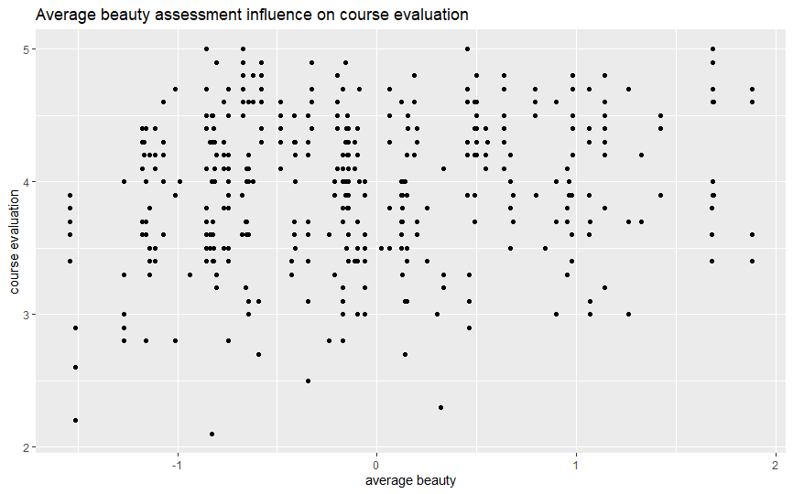

With alpha 0.2

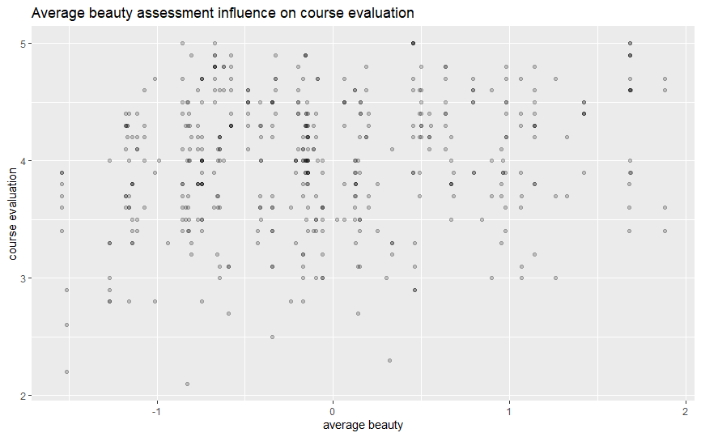

From the graphs above, the least course evaluation point was not the instructor with the least average beauty. The least evaluation score was around average beauty of 2.2 was an instructor far from the least average beauty of -1.6. Also, the highest evaluation score (5) was spread between instructors with less and more average beauty. For example, instructors with average beauty of – 0.8, - 0.6, 0.4 and 1.7 scored the highest point. From the graph, most of the observation was clustered between average beauty of 0.5 or less. This implies that beauty has less influence on course evaluation instructors receive. And the beauty of an instructor does not determine the score.

**Question 5**

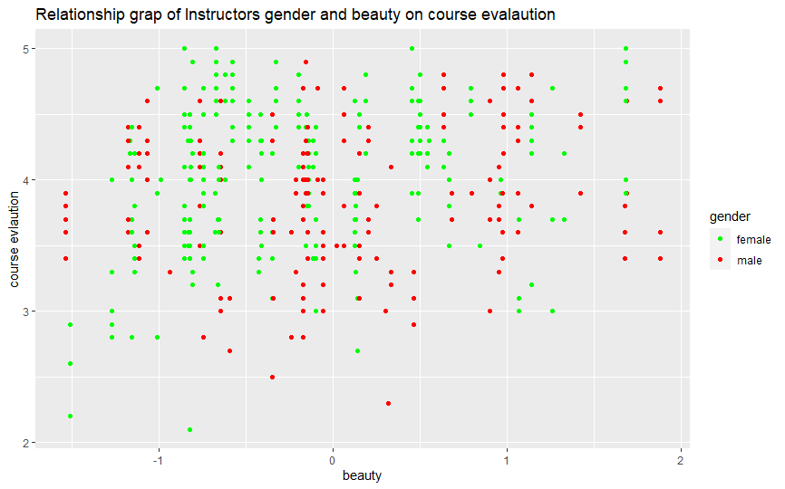

The graph has more female scoring higher in course evaluation. The red points which represents males are clustered between 3 and 4 of the course evaluations. Majority of the male and female instructors were scored between -1 and 1 on the beauty scale. Male instructors received the lowest (-1.48) and highest (1.8) beauty scores. The female instructors received the lowest (2.1) and highest (5) evaluation scores. Based on the high evaluation score among female instructors, they have higher chances of winning awards, grants, promotion and tenure track positions.

On the lower end of the beauty score, there is a close score for male and female instructors (-1.49 for females and -1.48 for males). In contrast, on the higher end of the beauty score, there is a wider gap between male and female scores (1.7 for females and 1.9 for males).

Question 6

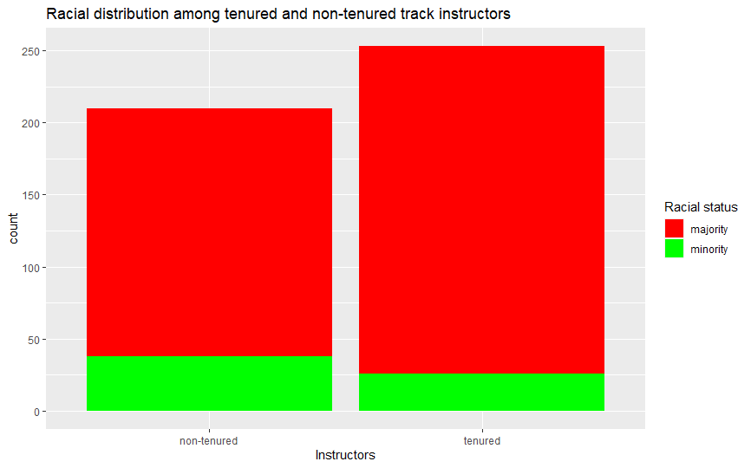

The distribution shows that the racial majority are more than minority in both tenure and non-tenure instructors. The administration should consider employing instructors within the racial minority group to promote diversity. Much effort should be channeled into the tenured track instructors since the gap is very wide. Among the minority instructors, non-tenured track instructors (75) are more than tenured track (25). However, among the majority instructors, tenured track members (225) are more than non-tenured instructors (200). While I recommend more minorities to be appointed by the school, there should be increased efforts to offer tenured track positions to employed minority members. In the interim, administrators could hold off on employing instructors within the majority race to ensure a more equitable faculty.

**Question 7**

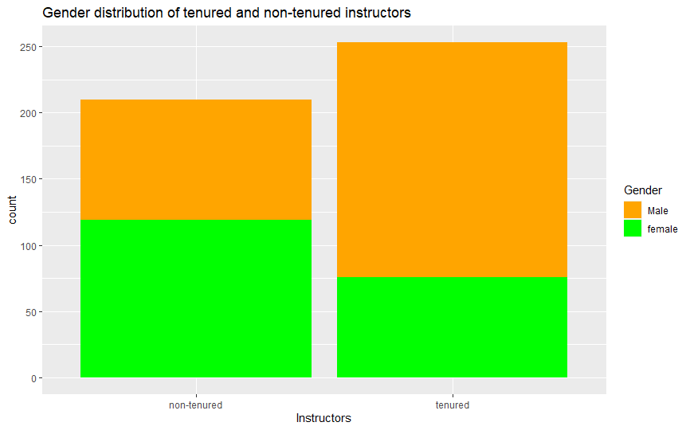

From the diagram, there are more non-tenured female instructors (123) than the male non-tenured (80). On the other hand, the male tenured track instructors (180) are more than the females tenured track instructors (75). Among non-tenured track instructors, there are 43 more females than men. On the other hand, there are 105 less female than male in the tenured track positions. The administration should employ a strategic plan in appointing instructors to promote gender balance. Further, the administration should priorities filling tenure track positions with females over males to ensure increase opportunity for females.